Main System Screen: 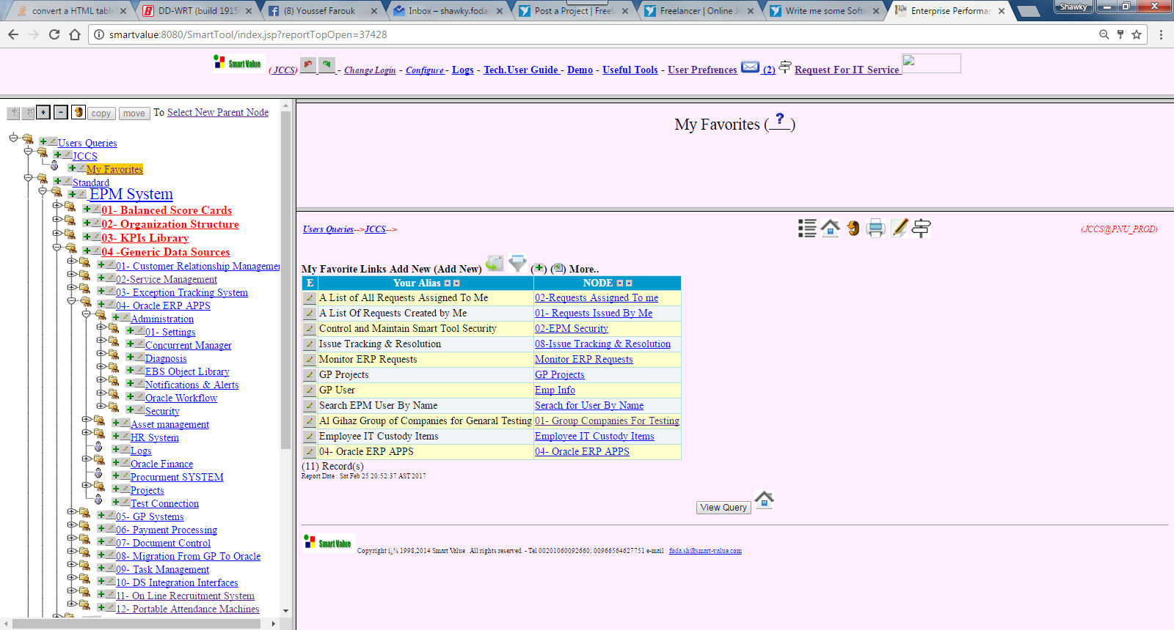

Sample Multi Section Screen (Readonly) :

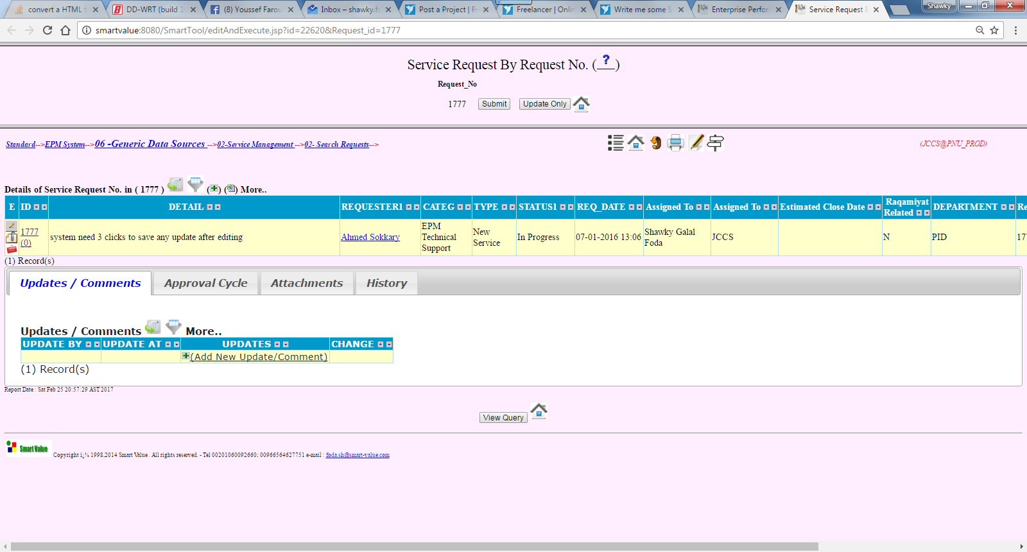

Sample Multi Section Screen ( With Editing ability ) :

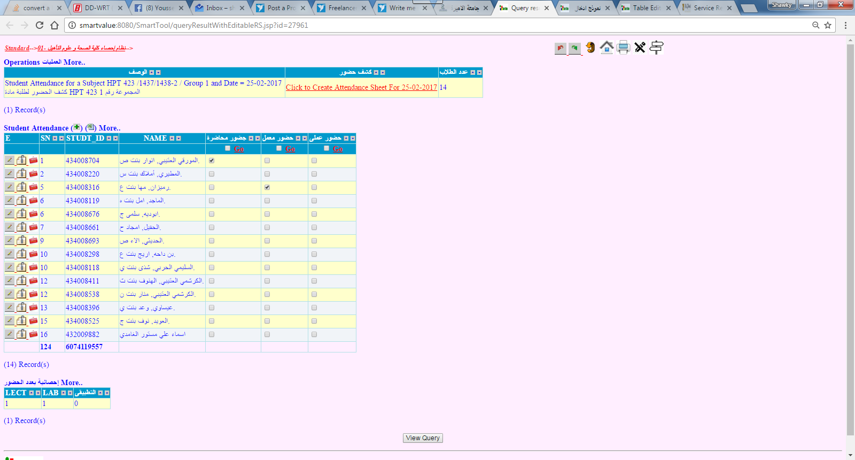

Sample Object Editor Screen :

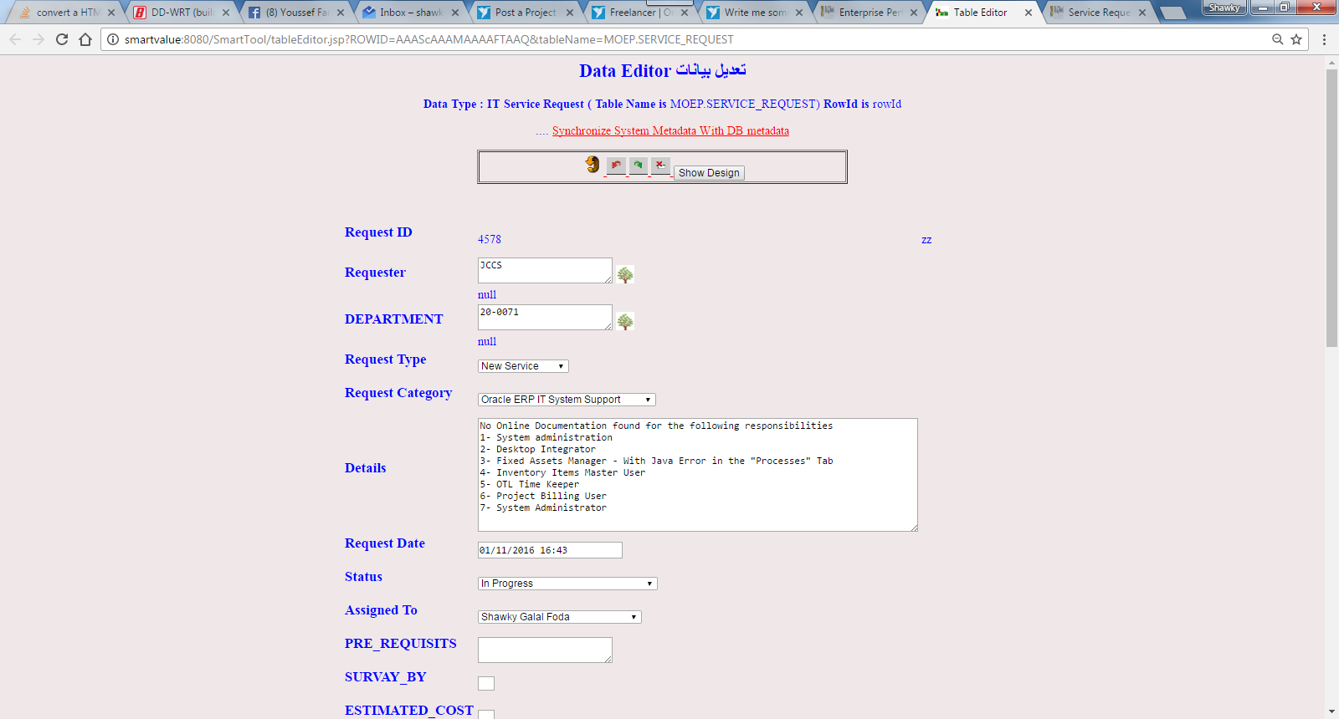

Sample Object Creation Screen:

